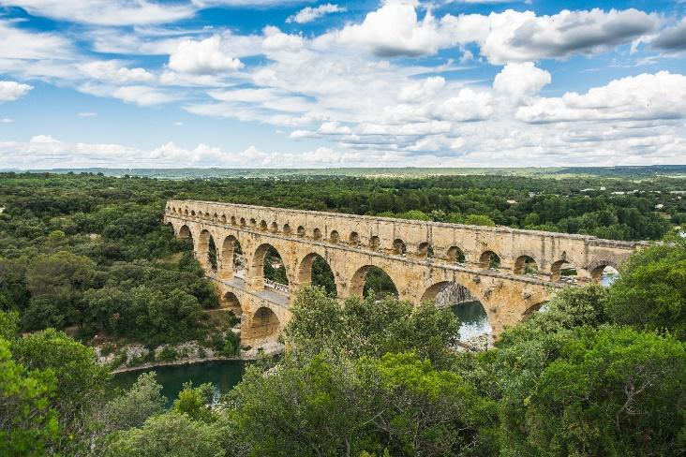

**Science** As scientists we will be spending half the term looking at Plants and the other half term studying LIGHT which will include creating a Shadow Puppet play. As usual this will include learning how to work scientifically including: planning investigations, drawing tables and discussing fair testing. The Continuous Provision table will provide opportunities for each child to have time to explore each area in greater depth, for example, comparing the difference between primary and secondary colours in paint compared with those in light.

**English:** As writers we will be developing our writing skills, looking at how to write a detailed report and then in the last half term writing our own story book for a year R child. Our work on Spelling, punctuation and grammar will continue and we will be undertaking more challenging comprehension papers. The Free Readers have enjoyed compiling a Newspaper…I wonder what they will want to tackle next!?

**P.E.** There will be a variety of sports this term, with the Young Leaders continuing to play an important role and weekly swimming becoming part of our last half term’s activities…as well as preparing for Sports Day.